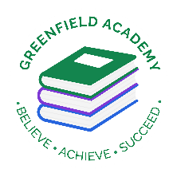
Greenfield Primary Academy
Year 4
Autumn Term 1 Learning Letter 2022
In Maths we are learning to …
In Maths, we will be exploring numbers up to 4 digits and addition and subtraction, and we will be:
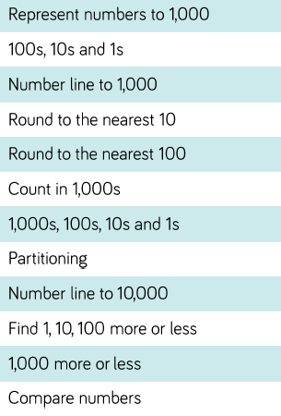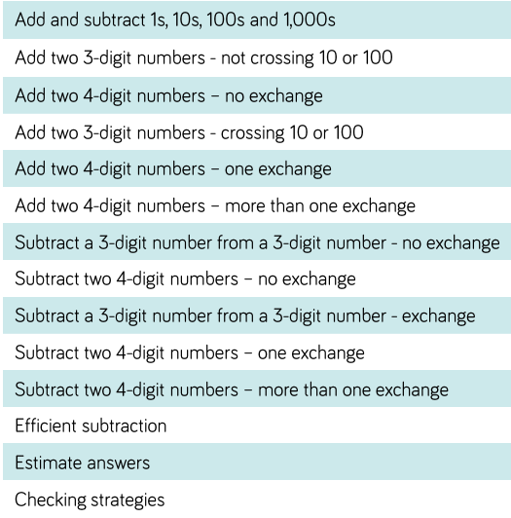
In English we are learning to …
Write in different ways: we will be looking at the features of adventure stories, traditional tales/fables, instructions and reports, and writing our own too.
Read more fluently: this term we will continue with whole class comprehension lessons in the same way as Year 3. Your child will have a reading book and will also have access to MyOn – our online reading program.
Understand Grammar: we will learn about:
Noun, verbs, adjectives, Apostrophes (contraction), Prepositions,
Alphabetical order, write different types of sentences (statements, questions, commands) and Find and use synonyms
Our Learning Theme is …
The UK
Land, Sea and Sky

States of Matter

In RE we are learning to …
What does it mean to be a Hindu in Britain today?
Describe some examples of what Hindus do to show their faith, and make connections with some Hindu beliefs and teachings about aims and duties in life. Describe some ways in which Hindus express their faith through puja, aarti and bhajans. Suggest at least two reasons why being a Hindu is a good thing in Britain today, and two reasons why it might be hard sometimes.
In Art we are learning to …
- Use different grades of pencil to shade
- To understand different techniques used by artists
- To understand tone and texture
- To use watercolours in the style of J Turner
- To show reflections in art
- To know how to use different brushstrokes to create tone and texture

In Geography we are learning to …
- Identify where each of the countries in Europe are.
- Identify the countries of the UK, their location and the name and location of their capitals.
- Know the names of the seas around the UK.
- Name and locate cities of the UK.
- Understand where we live and how it links to other places.
- Describe the human features of UK regions, cities and countries.
- Use geographical words such as valley, erosion, transportation, headland.
- Understand how hills, rivers etc. affect where people live.
- Develop our orienteering skills
In Science we are learning that …
Materials exist in three ‘States of matter’

In our Summer 1 topic, we explore states of matter. This starting point allows the children to develop a great foundational understanding of solids, liquids and gases, and how the particles behaved within them. Children obtain the knowledge by carrying out a range of investigations. This is the first-time children will encounter States of Matter, but it builds the foundations for the next unit within Y5. The children also learn about the water cycle, evaporation and condensation.

In RHE/ PSHE we are learning to …
- Understand what rules and responsibilities are and explain the school rules.
- Understand what manners are and courtesy is.
- Talk about democracy and why it is important.
- Understand what respect is and how to treat others with respect.
- Understand what an opinion is and give their opinions on different subjects.

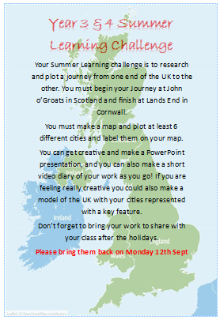
Geography: The British Isles
Your Summer Learning challenge is to research and plot a journey from one end of the UK to the other. You must begin your Journey at John o’Groats in Scotland and finish at Lands End in Cornwall.
You must make a map and plot at least 6 different cities and label them on your map.
You can get creative and make a PowerPoint presentation, and you can also make a short video diary of your work as you go! If you are feeling really creative you could also make a model of the UK with your cities represented with a key feature.
Don’t forget to bring your work to share with your class after the holidays.
Please bring them back on Monday 12th Sept

Deadline for this project is September 13th. The Home Learning Challenge poster will be displayed at the class parent notice board window.

Year 4 Half Term Learning Project
Year 4 Weekly Home Learning Tasks
READING
Please share your child’s reading book with them, as 10-15 minutes of reading every day at home can make a lot of difference to your child's reading ability.
Your child MUST bring their book bag into school every day so an adult can read with them on their reading day, and any extra days if there is an opportunity.
Each child will have a reading book, and an extra book from the class library.
Every child will have an online MyOn account where they can read books and answer questions. This is in addition to their daily reading book task.
MATHS
Every child has a TTRockstars, they can use these to practise their times tables facts online as it is important times tables are learnt for this year. 10 minutes every day will mean that they are ready for their times tables test in Summer, and will make them much quicker at working things out in class.
PURPLE MASH
Each week the children will be set several tasks on Purple Mash. They log on to their account and complete their tasks. When they log on, there is a bell at the top of the screen. When they click on this, it will show them all the tasks they need to complete for that week.
Tasks are allocated on a Friday and have to be completed by the following Tuesday. There is usually a grammar, writing, spelling, maths and either a science or geography task.

