Year 3

Half term project

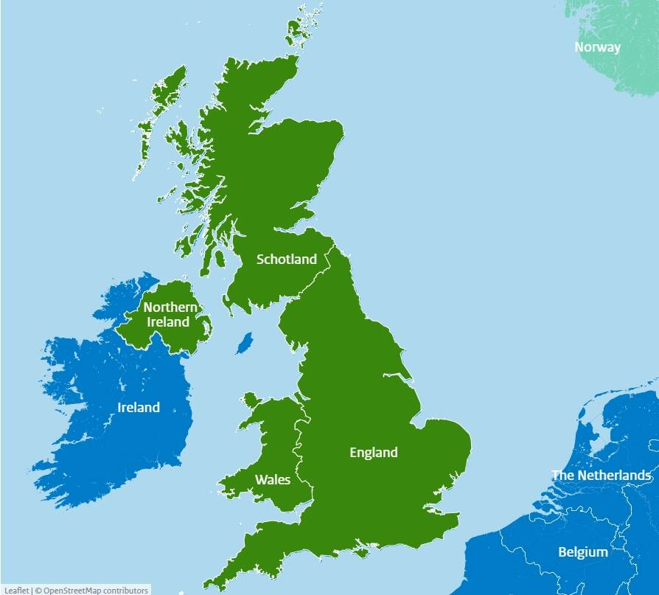

Your Half Term Learning project is to research and plot a journey from one end of the UK to the other. You must begin your Journey at John o'Groats in Scotland and finish at Lands End in Cornwall.

You must make a map and plot at least 6 different cities and label them on your map.

You can get creative and make a PowerPoint presentation, and you can also make a short video diary of your work as you go! If you are feeling really creative you could also make a model of the UK with your cities represented with a key feature.

Don’t forget to bring your work in to share with your class.

**Please bring them back on Wednesday 1st October**