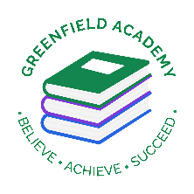**Greenfield Primary Academy**

**Year 4**

**Summer Term 2 Learning Letter 2025**

**In Maths we are learning about…**

**Place value: We will be continuing to use place value with 4 digit numbers and we will also be learning Roman Numerals**

**Multiplication and division: We will continue to use formal calculations to multiply and divide larger numbers.**

**Fractions: We will recognise and write decimal equivalents.**

**Area and perimeter: We will be calculating the area and perimeter of rectilinear shapes.**

**Capacity: We will be estimating, comparing and converting different units of measures.**

**Memorise times tables. The children will be having a formal assessment of their times tables at the beginning of the term and will need to know both the multiplication and division facts for all tables up to 12. Children need to use TTRockstars daily at home, and we will have an assessment in school each week.**

**In English we are learning to …**

**Write in different ways:** We will learn about reading and writing fantasy stories. We will use the story ‘How to train a dragon’ to write setting and character descriptions, as well as our own fantasy stories. We will also look at the text from Lindisfarne and write newspaper reports.

**Read more fluently:** this term we will continue comprehension lessons three times a week. We will be learning to answer literal, deductive and inference questions. Your child has a reading book and will also have access to MyOn – our online reading program. We try to read with them at least once a week.

**Understand Grammar:** We will consolidate our knowledge of prepositions and will start to look at using brackets to add extra detail to sentences. We will consolidate our knowledge of Fronted adverbials, direct and indirect speech and the use of passive voice.

off

**In RE we are learning about…..Why do some people think that life is a journey? What significant experiences mark this?**

• Suggest why some people see life as a journey and identify some of the key milestones on this journey

• Describe what happens in Christian, Jewish, and/or Hindu ceremonies of commitment and say what these rituals mean

• Suggest reasons why marking the milestones of life are important to Christians, Hindus and/or Jewish people

**In Design Technology we are learning to …**

**• Design a project that is strong and aesthetically pleasing**

**• Make a product using suitable materials that meets the design brief**

**• Look at our work and improve on our designs as we make it.**

**• Evaluate whether our work has met the design brief and talk about how we can improve next time.**

**We will be making Aqueducts and developing our design and making skills.**

**Our Learning Theme is …**

## Invaders and Settlers

**Living things and their habitats.**

**In Science we are learning about … Living things and their habitats**

**We will:**

-    recognise that living things can be grouped in a variety of ways

-     explore and use classification keys to help group, identify and name a variety of living things in their local and wider environment

-    recognise that environments can change and that this can sometimes pose dangers to living things.

(Animals including humans)

**-**    construct and interpret a variety of food chains, identifying producers, predators and prey.

**In History we are learning to …**

* Place some historical periods in a chronological (time) order
* Use historic terms related to the period of study.
* Use sources of information in ways that go beyond simple observations to answer questions about the past.
* Use a variety of sources to find out about aspects of life in the past.
* Communicate learning in an organised and structured way, using appropriate terminology.
* Describe a study of Anglo-Saxon life and achievements and their influence on Britain.

**In RHE/ PSHE we are learning about … First aid.**

In Year 4, children will learn how to make an emergency call, how to keep safe in an emergency and some basic First Aid which again is a very important life skill for the children to have.

At the end of Summer 2, they will also look at their aspirations and base this around transition to their next year group.

**Our Home Learning Project fits in with Our topic for the Summer term, which is Invaders and Settlers. We will begin our learning with the Anglo Saxons. For your Home learning I would like you to research and make an Anglo Saxon Roundhouse out of any junk materials you might have. You need to complete and bring back into school before the end of the school year.**

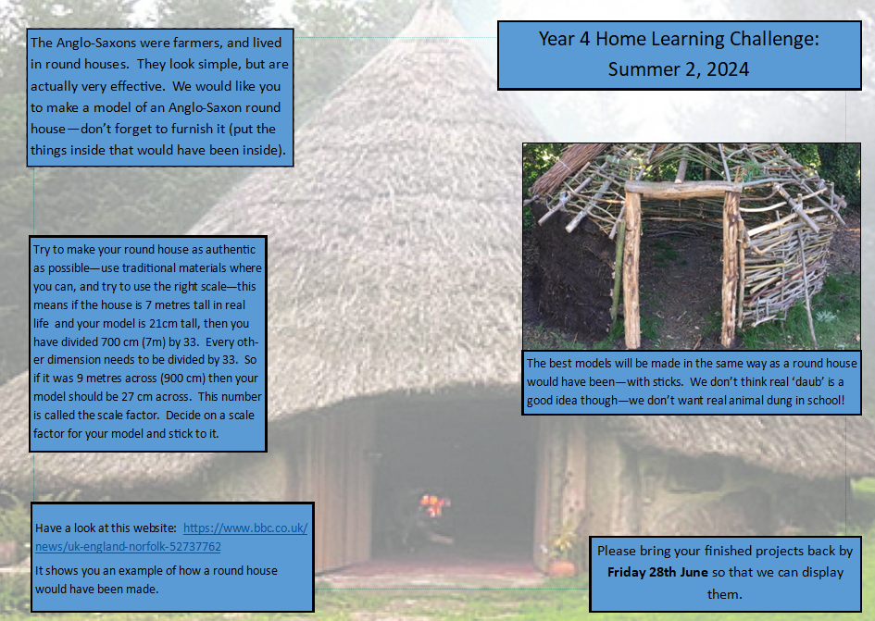

**READING**

Please share your child’s reading book with them, as **10-15 minutes** of reading **every day** at home can make a lot of difference to your child's reading ability.

Your child MUST bring their book bag into school **every day** so an adult can read with them on their reading day, and any extra days if there is an opportunity.

Each child will have a reading book, and an extra book from the class library.

Every child will have an online Myon account where they can read books and answer questions. This is in addition to their daily reading book task.

**MATHS**

Every child has a TTRockstars and Sumdog account. They can use these to practise their times tables facts online. 10 minutes **every day** will mean that they are ready for their times tables test next term.

**Year 4 Half Term Home Learning Project**

**Year 4 Weekly Home Learning Tasks**