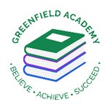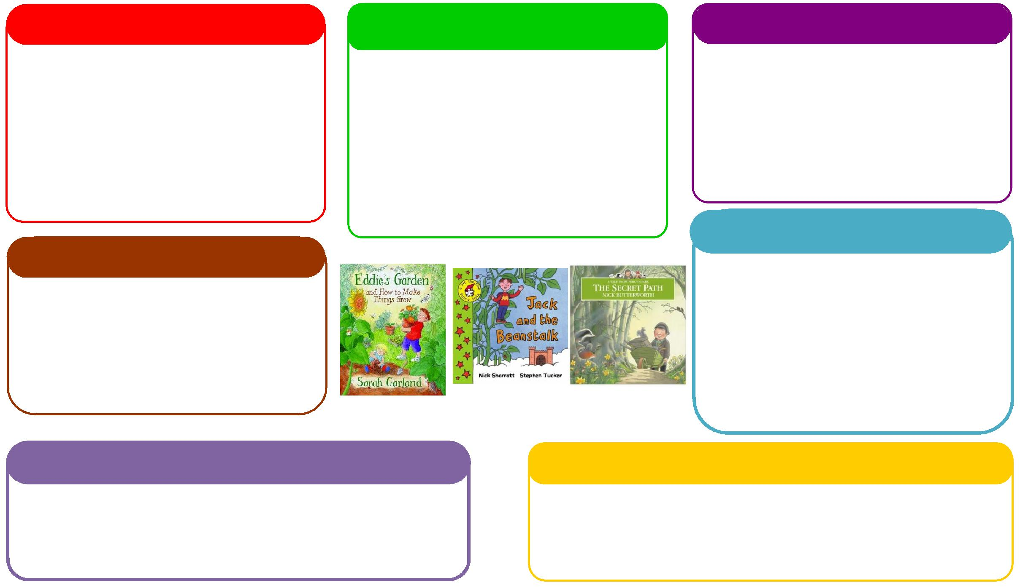

This half term we will be:

* Spatial reasoning - Reception
* Building numbers beyond 10 - Reception
* Doubling and halving – Reception
* Counting to 10 – Nursery,
* Repeating patterns – Nursery
* Learning about more and Less - Nursery

**Learning Letter Summer 1 EYFS**

Growth and Change

This half term we will be:

* Looking at the key features of the life cycle of a plant.
* Growing our own plants and herbs,
* Planting beans and discussing how they change,
* Comparing different environments.

**Expressive Arts and Design**

**Personal, Social and Emotional Development**

**Understanding the World**

**Physical**

**Mathematics**

**Communication and Language**

**English**

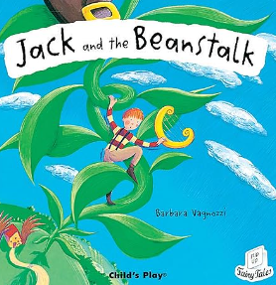 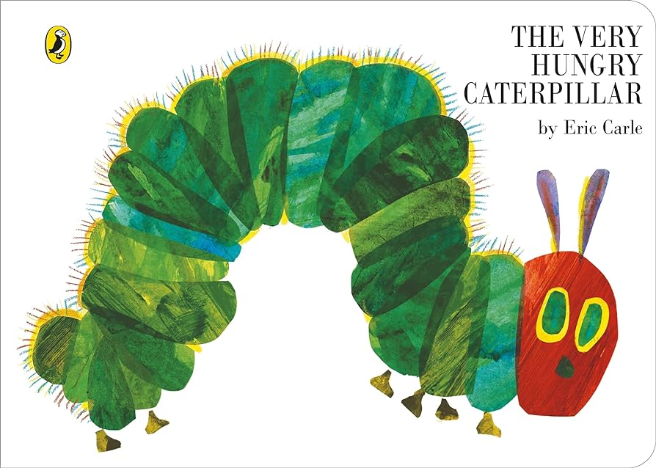

This half term we will be:

* Discussing with our friends what we got up to in the holidays,
* Acting out different stories together,
* Using the language of explanation to explain different animal life cycles,
* Talking about seasonal changes.

This half term we will be:

* Introducing the artist, Andy Goldsworthy.
* Having dance lessons in the hall,
* Making pictures using natural resources. Focusing on cutting and layering techniques.

This half term we will be:

* Discussing what did children did during the holidays,
* Looking at the different characters in the story and how they are feeling,
* Using our Think Equal books during circle time.

This half term we will be:

* Retelling stories,
* Writing instructions on how to plant a bean,
* Writing about the life cycle of a caterpillar and acting out the story,
* Creating Jack and the Beanstalk books.

This half term we will be:

* Exploring healthy and unhealthy foods linked to the text Oliver’s Vegetables,
* Making vegetable soup using simple utensils and equipment to mix, grate and squeeze safely,
* Using our skills from Little Bikers to practice riding our new balance bikes.

**EYFS Half Term Learning Project**

**Can you plant a seed at home? What does the seed need to grow? What have you grown? Can you measure how tall it has grown?**