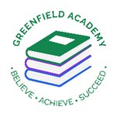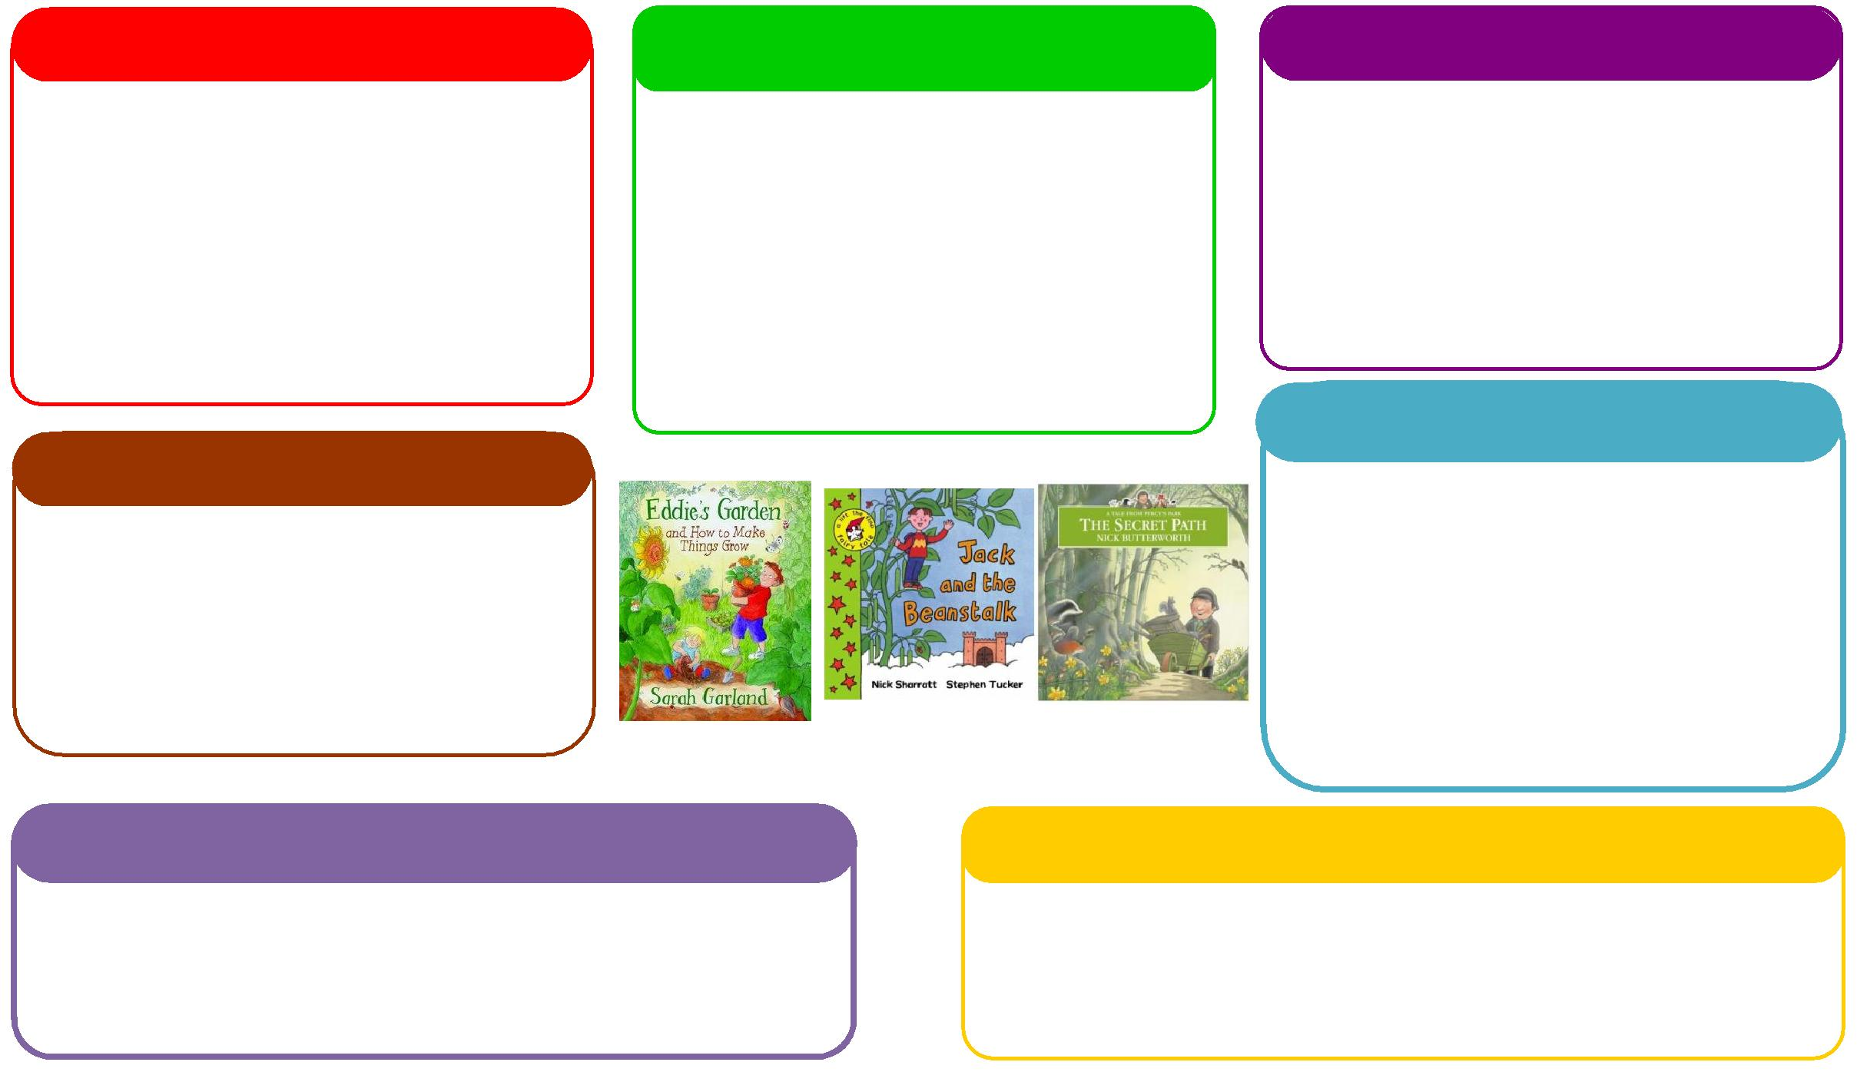

This half term we will be:

* Researching dinosaurs and learning about the palaeontologist Mary Anning,
* Going on a trip to the farm,
* Programming Bee Bots,
* Learning about Easter and why it is special.

**Expressive Arts and Design**

**Personal, Social and Emotional Development**

**Understanding the World**

**Physical**

**Mathematics**

**Communication and Language**

**English**

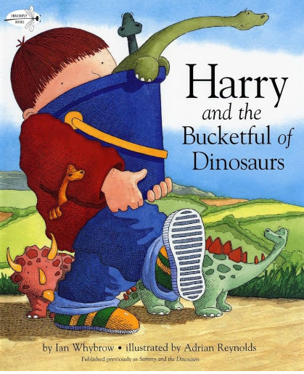 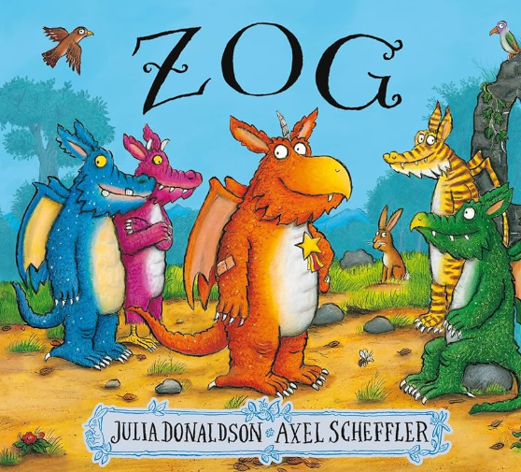

This half term we will be:

* Practical subtraction
* Missing number calculations within 5,
* Missing number calculations within 10,
* Spatial reasoning,
* Starting to chant in tens and twos.

This half term we will be:

* Discussing with our friends what we got up to in the holidays,
* Acting out different stories together,
* Using Modern tales to inspire our own helicopter stories,
* Talking about seasonal changes

**Learning Letter Spring 2 EYFS**

Modern Tales

This half term we will be:

* Creating dinosaur crafts,
* Having dance lessons in the hall,
* Making Easter crafts,
* Learning new songs and rhymes,

This half term we will be:

* Discussing our half term holidays and what we got up to,
* Looking at the different characters in the story and how they are feeling,
* Thinking about how to live a healthy lifestyle.

This half term we will be:

* Using our phonics knowledge to write words and simple sentences,
* Retelling stories,
* Researching dinosaurs and writing facts on them,
* Creating ZOG books.

This half term we will be:

* Making magic wands with sticks outside for large arm moment,
* Digging and planting outside,
* Exploring the weaving area outside,
* Introducing Yoga into our daily timetable,
* Learning a dinosaur dance.

**EYFS Half Term Learning Project**

**What do you know about dinosaurs? How many books can you read about dinosaurs? What have you learnt? If you don’t have any books at home, why don’t you visit Hyde library? Create some art to represent your favourite dinosaur. This could be a paper mâché model of a T-REX, a painting of a stegosaurus or an idea of your own!**