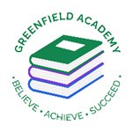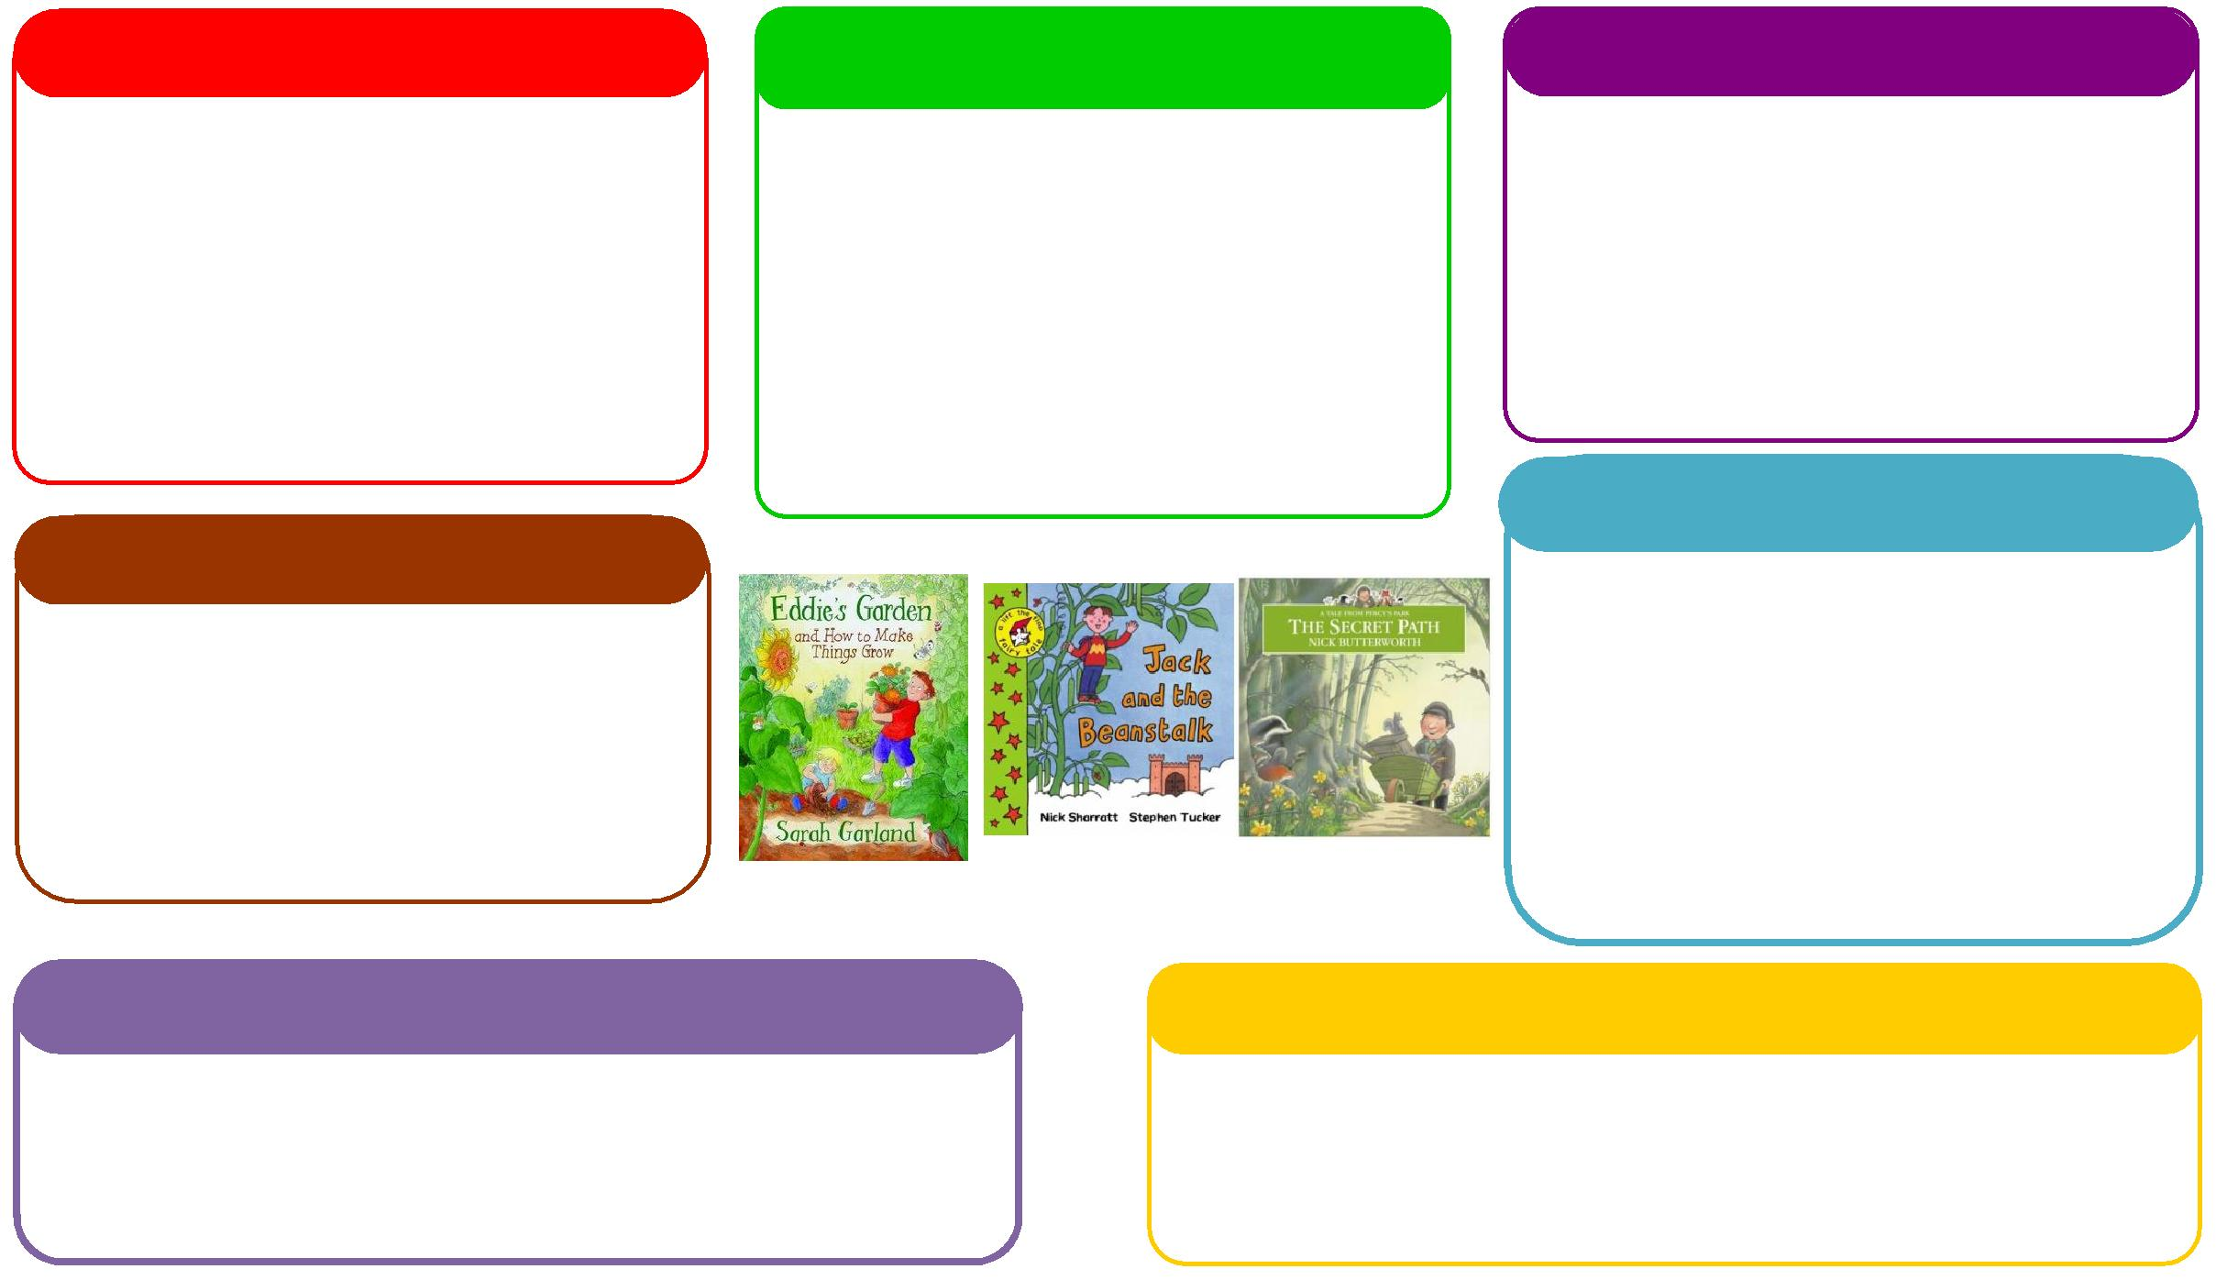

This half term we will be:

* Making porridge linked to our text choice The Magic Porridge Pot,
* Discussing and learning all about similarities and differences through festivals and celebrations,
* Walking to the woods to look at seasonal changes and creating a weather chart in class.

**Expressive Arts and Design**

**Personal, Social and Emotional Development**

**Understanding the World**

**Physical**

**Mathematics**

**Communication and Language**

**English**

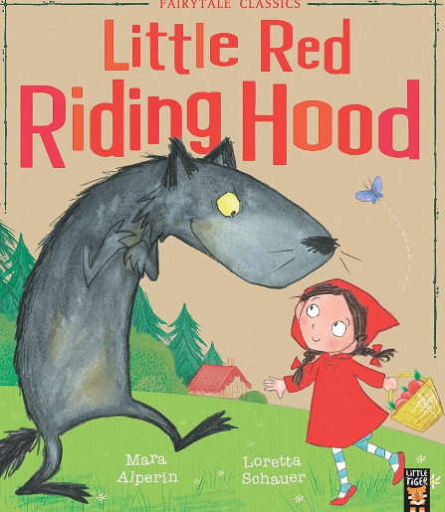 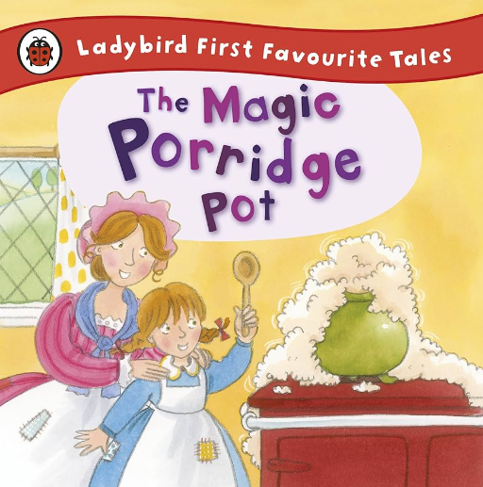

This half term we will be:

* Finding 1 more and 1 less,
* Ordering and writing numbers,
* Learning about size,
* Subitising,
* Solving lots of additional problems using practical objects.

This half term we will be:

* Discussing with our friends what we got up to in the holidays,
* Acting out different stories together,
* Using traditional tales to inspire our own helicopter stories,
* Talking about seasonal changes

**Learning Letter Spring 1 EYFS**

Traditional Tales

This half term we will be:

* Creating Little Red Riding Hood crafts,
* Having dance lessons in the hall,
* Learning how to use powder paints,
* Learning new songs and rhymes,

This half term we will be:

* Discussing our half term holidays and what we got up to,
* Looking at the different characters in the story and how they are feeling,
* Thinking about how to live a healthy lifestyle.

This half term we will be:

* Using our phonics knowledge to write words and simple sentences,
* Retelling stories,
* Writing instructions on how to make porridge,
* Creating Little Red Riding Hood books.

This half term we will be:

* Manipulating playdough to create porridge pots,
* Exploring healthy and unhealthy foods linked to the text Hansel and Gretel,
* Doing Dough disco to build our finger strength
* Focusing on movement skills in PE.

**EYFS Half Term Learning Project**

**How many Traditional Tales can you read at home? Which is your favourite Traditional Tale? Why is this your favourite? Can you create some art work in response to this story?**